Capstone 2

Project Documentation
Team: Torque Titans
Team members: Aws Abu Ali, Nipun Gunarathne, Daniel Trubek Ferencs-Csiki Daniel, Patrik Kaczur
Abstract
This project focuses on the development of a non-motorized vehicle equipped with a rocker-bogie suspension system, designed to navigate heavy terrain effectively. The objective was to create a lightweight, durable, and cost-efficient vehicle while adhering to strict dimensional and functional constraints. Through comprehensive research, various suspension systems were evaluated, with the rocker-bogie system being selected for its superior adaptability to uneven surfaces. The project encompassed conceptual design, 3D modeling, and fabrication of components while integrating sustainable practices like the use of recycled materials. The final outcome is a robust prototype capable of handling challenging terrains while maintaining stability and ease of assembly.
Introduction
Suspension systems play a critical role in vehicular stability and mobility, particularly for off-road and space exploration vehicles. These systems ensure the vehicle can traverse uneven terrain while maintaining traction, stability, and user control. This project explores the application of advanced suspension designs, specifically the rocker-bogie system, which has proven its effectiveness in planetary rovers like NASA's Mars rovers.
The primary objective of this project is to design, fabricate, and document a non-motorized vehicle with a focus on functionality, durability, and adherence to strict dimensional and budgetary constraints. The design process involved evaluating various suspension systems, selecting the most suitable one based on a decision matrix, and iteratively refining the design through prototypes. This documentation outlines the research, design methodology, fabrication processes, and key decisions that led to the successful completion of the project.
Summary about suspensions of vehicles
Suspension systems are very important for all vehicles, especially for off-road and space exploration vehicles. These systems help to keep the vehicles stable, absorb shocks, handle rough movements and maintain traction on rough surfaces. This review explains different types of suspension, their usage in off-road vehicles on Earth, and how they are adapted for Mars and Moon rovers.

Types of Suspension Systems
Here are the two main categories of suspensions which are used in automotive industry.

Dependent Suspension
This system connects both wheels on the same axle. It is also called solid axle or live axle suspension, one of the simpler suspension systems. It is strong and is used in older vehicles, heavy-duty and off-road vehicles. The support comes from leaf springs or coil springs. They can handle tough conditions and are the primary suspension systems for rear-wheel-drive automobiles, and SUVs.
- Advantages: durability, simplicity and cost-effectiveness
- Disadvantages: limited wheel articulation, reduced comfort and uneven tire wear
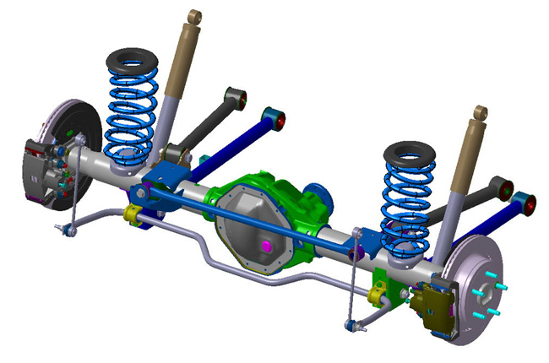
1. Figure: Dependent suspension 1

Independent Suspension
Independent suspension is popular in modern vehicles due to handling, comfort, and stability. This suspension type allows each wheel to move vertically independently of the others. It typically consists of a combination of control arms, shock absorbers, springs, and connecting links. It is common for the left and right sides of the suspension to be connected with anti-roll bars or other such mechanisms. The anti-roll bar ties the left and right suspension spring rates together but does not tie their motion together.
- Advantages: improved handling, enhanced comfort, reduced tire wear, ability to customize
- Disadvantages: complexity, higher cost, space requirements
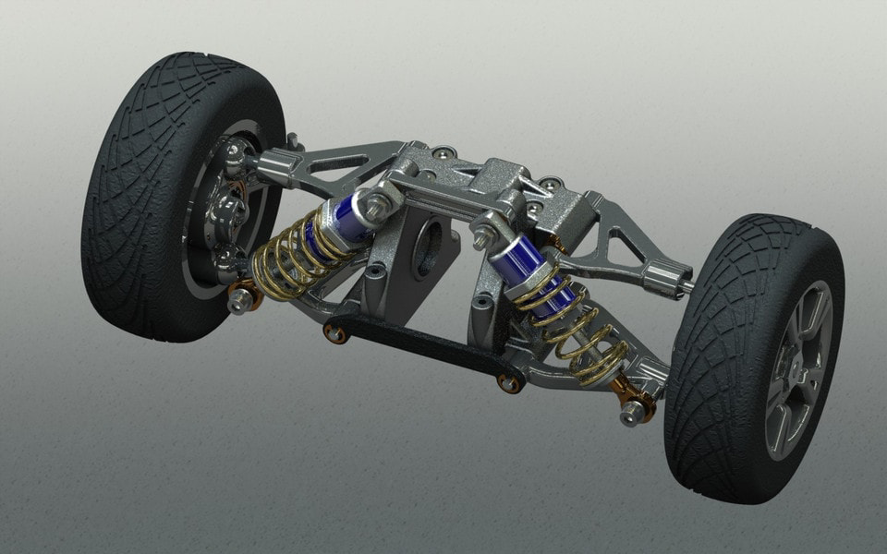
2. Figure: Independent suspension

Suspension of Off-Road Vehicles
These systems must balance articulation (keeping wheels grounded), durability (withstanding harsh conditions), and weight efficiency. Unlike space rovers designed for low gravity, Earth's off-road suspensions prioritize shock absorption and adaptability to ever-changing obstacles like rocks, mud, and steep inclines. The right suspension choice depends on the vehicle's purpose, from rock crawling to high-speed desert racing.
- Multi-link suspensions for precise wheel control
- Long-travel setups to absorb big impacts
- Air suspensions that adjust ride height automatically
- Durable leaf springs for heavy loads

Suspension in Planetary Rovers
Space rovers, like NASA's Mars rovers, use specialized suspensions such as the Rocker-Bogie System. This system ensures stability and ground contact in low-gravity environments, allowing rovers to traverse obstacles up to twice the wheel diameter.
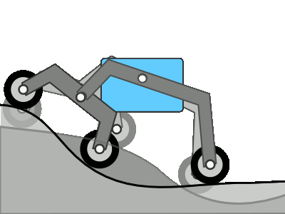

9. Figure: Rocker-Bogie suspension

Comparison
Aspect | Earth Off-Road Suspensions | Space Suspensions (e.g., Moon/Mars Rovers)
Primary Purpose | Provide stability, comfort, and handling on rough terrain | Maintain stability and ground contact in low-gravity environments
Key Components | Coil springs, leaf springs, shock absorbers, air suspensions | Lightweight mechanical linkages, flexible wheels, passive suspensions
Shock Absorption | Essential for absorbing bumps, rocks, and vibrations | Minimal due to low gravity; focus on terrain adaptation
Adaptability | Often adjustable for different loads and terrains | Typically fixed; designed to handle expected terrain types
Weight Consideration | Less constrained by weight | Must be lightweight for launch and mobility efficiency

Project goals and requirements
This project aims to design and build a non-motorized vehicle while adhering to specific technical and functional constraints. The primary goals include:
- Comprehensive Planning and Design: Developing a detailed project plan, conducting literature reviews on suspension systems and off-road vehicles (e.g., Mars and Moon rovers), and proposing at least three suspension concepts, one of which will be selected via a decision matrix.
- Engineering and Fabrication: Creating detailed designs for 3D-printable parts using CAD or manual design methods, as well as designing and integrating additional components to complete the vehicle.
- Documentation and Deliverables: Producing comprehensive documentation that includes team roles, literature references, conceptual designs, decision matrix details, the finalized concept, a budget plan, component list, and technical drawings (individual and assembly).
Requirements and Constraints
- Physical and Dimensional Constraints:
  - Total vehicle dimensions must not exceed 28 × 14 × 14 cm.
  - Maximum dimensions for 3D-printed parts are 20 × 14 × 14 cm, with a limit of 20 pieces.
  - Wheel diameter is capped at 8 cm but may be self-designed.
  - The vehicle’s self-weight must remain below 0.6 kg.
- Functional Specifications:
  - The vehicle must accommodate a flat surface for attaching additional mass (up to 1 kg) and an acceleration sensor.

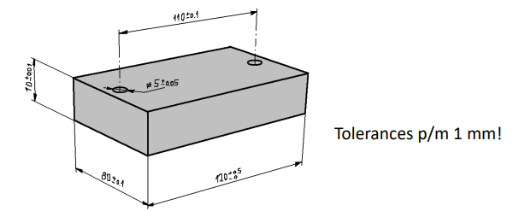
10. Figure: Additional weight specifications

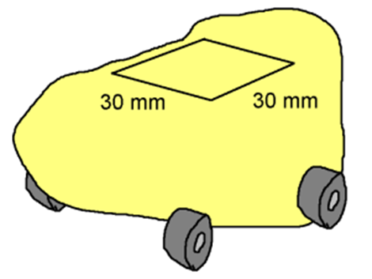
11. Figure: Acceleration sensor specifications

  - A towing cable attachment is required with a minimum 5 mm inner diameter hook or clip.
  - Recycled materials are encouraged for sustainability.
- Budgetary Limits:
  - Costs for off-the-shelf non-3D-printed components must not exceed 12,000 HUF.
The vehicle design prioritizes functionality, low weight, and stability while ensuring ease of testing and adaptability for various conditions.

Progression reports
Milestone 1

- Recap from the Milestone 1 about the Final design and the budget plan.

Final design
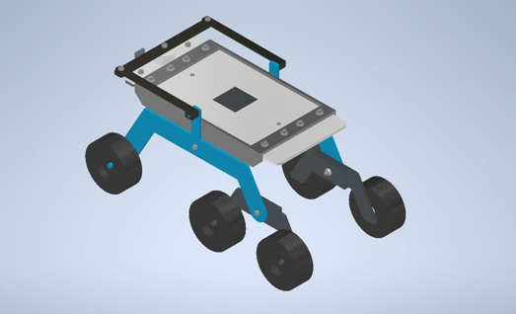
12 Figure. Milestone 1 Final Design 1

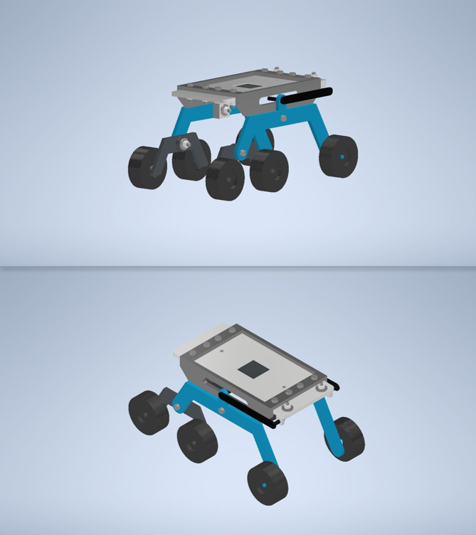
13 Figure Milestone 1 Final Design 1 1
Budget Plan
Budget Plan
Wheels | 720HUF/wheel - 4320HUF
Screws | Around 10HUF/each - 170HUF
Nuts | Around 5HUF/each - 85HUF
Washers | Around 2.5HUF/each - 42.5HUF
PLA Filament | Approximately 400g around 4000-5000HUF
Total Cost | Approximately 9040.5HUF

- Short literature reviews on different types of 3D printers and their capabilities.
Fused Deposition Modelling (FDM)

Fused Deposition Modelling (FDM) is one of the most widely used 3D printing methods, particularly popular at the consumer level. Often likened to a "hot-glue gun" approach, FDM printers work by extruding melted thermoplastic layer by layer to create a model. This method is ideal for producing quick, low-cost proof-of-concept prototypes, making it a staple in design and engineering fields. FDM printers are available in a wide range of sizes and price points, making them especially accessible and suitable for beginners.

Stereolithography (SLA)

SLA, developed in the 1980s, is a 3D printing method that uses a light source—originally a laser, now often a digital light projector—to cure liquid resin layer by layer. Though slower to adopt due to higher costs and complexity, it offers excellent surface finish, tight tolerances, and high accuracy. SLA is ideal for functional prototypes, end-use parts, and tooling that closely resemble injection-molded products.

Selective Laser Sintering (SLS)

SLS is a widely used industrial 3D printing method trusted for producing strong, functional parts. It works by using a high-powered laser to fuse polymer powder, with unused powder serving as built-in support. This allows for complex geometries without additional structures. SLS offers great design freedom and is ideal for batch production. Nylon is the most common material, valued for its strength and durability similar to injection-molded parts.

- Comparison of 3D printers
Feature | FDM | SLA | SLS
Material | Thermoplastic filament | Liquid resin | Nylon powder
Strength | Moderate | Moderate | High
Accuracy | Moderate | High | High
Surface Finish | Rougher, visible layers | Very smooth | Slightly grainy
Supports Needed | Yes | Yes | No (powder acts as support)
Ideal For | Basic prototypes, hobby use | Detailed prototypes, molds | Functional parts, industrial applications
Cost | Low | Moderate to High | High

Milestone 2
- Identifying the issue and adding changes to the final design model.

Issues related to the design
- Rocker arms being too long.
- Some parts were not printable.
- Height is too much that can result in a failure in the inclination test.

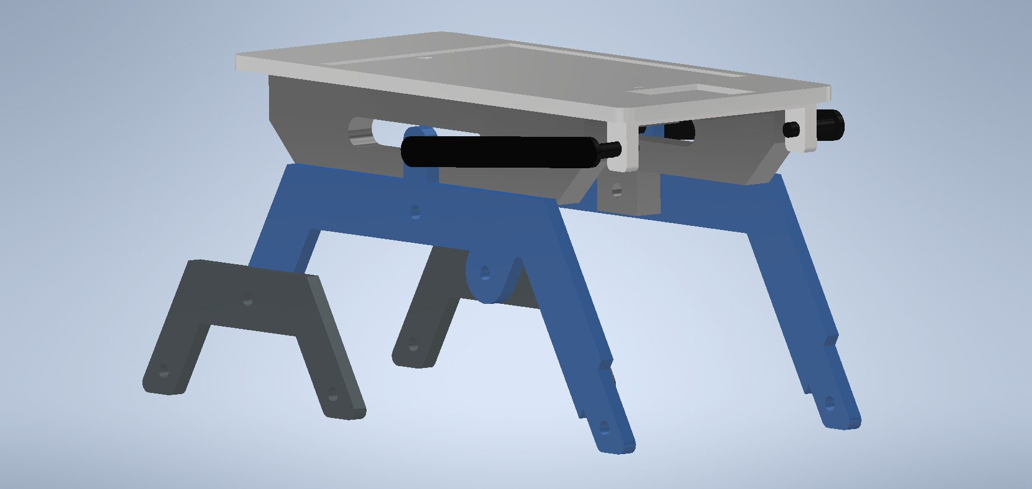
14 Figure Side view 1

Changes added to the model
- Making shorter arms
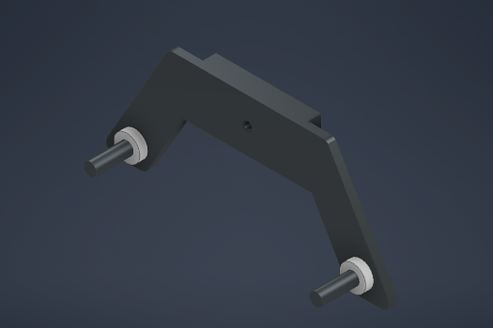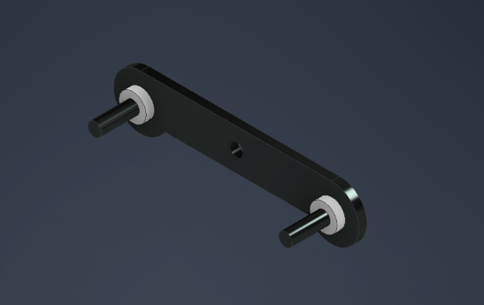
16 Figure new
15 Figure old
- Rocker arms were revoked to reduce the height and improve the functionality of suspension.
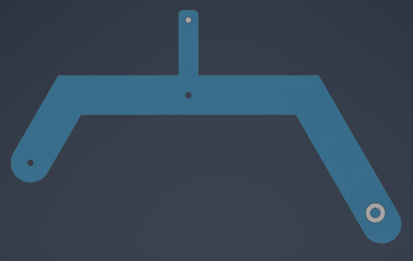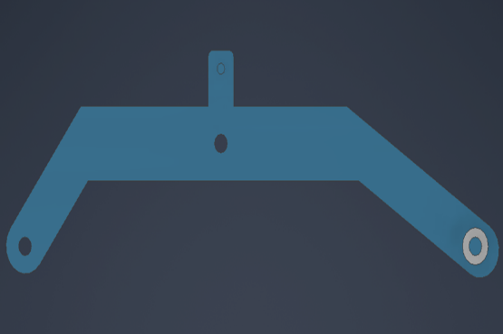
18 Figure new
17 Figure old
150
120
- Redesigned top plate for easy printing.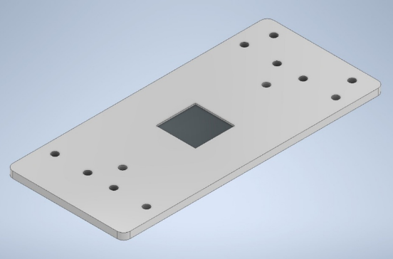 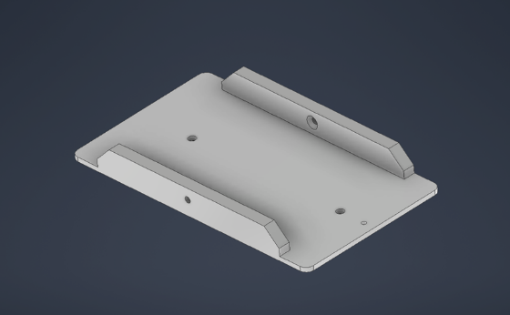
20 Figure new plate
19 Figure old plate

3D printed parts
- Flat surface plate
- Support housing
- Rocker arm
- Bogie arm
- Differential
  - Stabilizer pivot
  - Pivot mount
- 6 Wheels.
Additional components
- Screws: DIN EN ISO 1207
  - M3x10/10pcs
  - M3x16/2pcs
  - M3x8/2pcs
  - M3x25/1pcs
  - M3x20/2pcs
- Nuts: AS 1237 (3.1) 3 mm/17pcs
- Washers: DIN EN 24036 M3/17pcs

Milestone 3
1.Slicing, generating G code and printing the parts
G code information
Bed temperature: 50 degrees Celsius
Nozzle size: 210
3 loops were used outside
Slicing
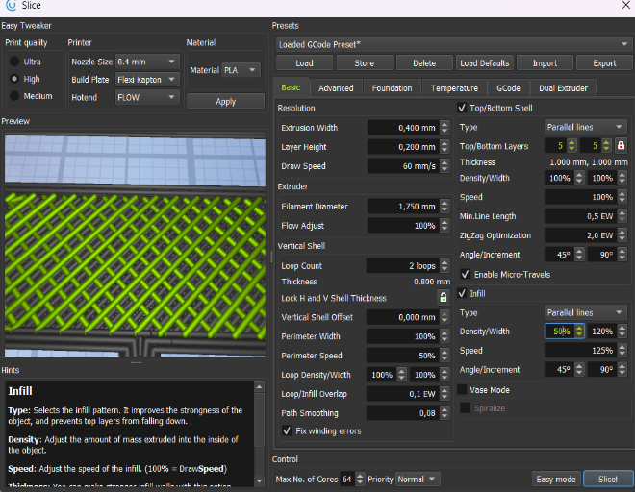
21 Figure slicing 1 1
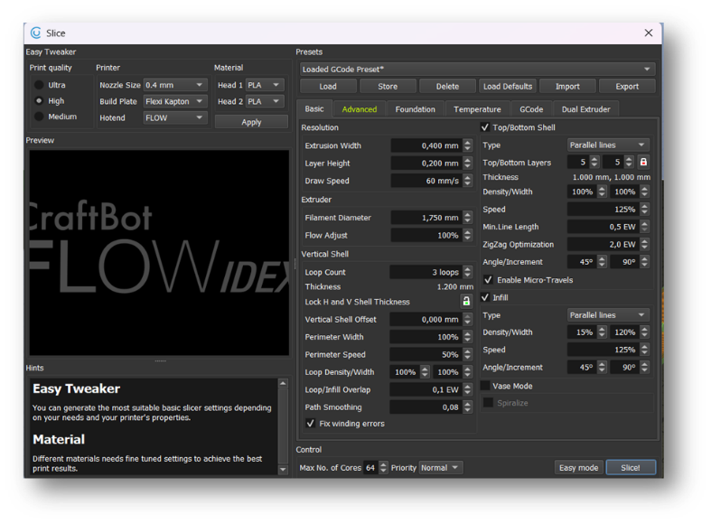
  - igure slicing 2 1
Printing
- The printing was done in two parts. At the same time the top plate was printed in one printer while the other parts were printed in another printer.
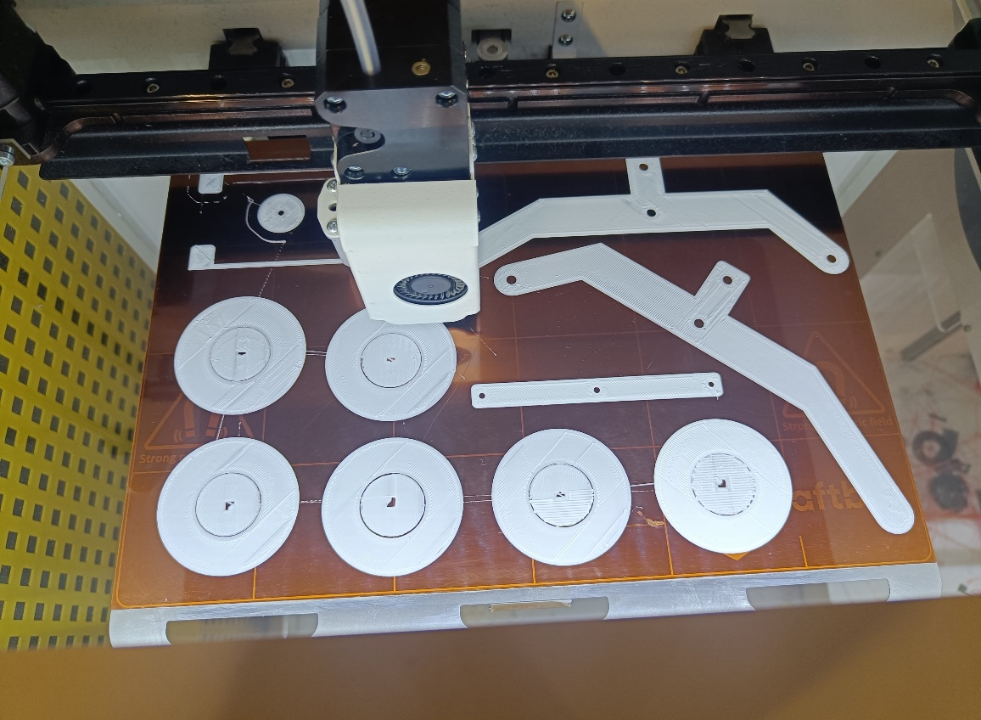
23 Figure printing in progress 1
Milestone 4
1.All the parts were made, the assembly and the testing started
Assembly plan
Prepare the Base Frame
Assemble the Rocker-Bogie Arms
- Attach the rocker arms (blue rocker arms) to the chassis using appropriate bolts and pivot points.
- Secure the bogie arms (smaller black arms) to the main rocker arms using the provided pivot mechanisms.
Attach the Wheels
- Insert the axles into the wheels.
- Attach the wheels to the rocker-bogie arms on both sides. Ensure the wheels are tightly secured and rotate freely.
Install the Support Brackets
- Attach the black support brackets on the top of the chassis using screws or bolts.
- These brackets may be used for stability or to hold additional components.
Final Tightening and Testing
- Check all bolts, screws, and pivots to ensure they are secure.
- Test the assembly by moving the suspension to ensure smooth and independent movement of the wheels.
Final assembly
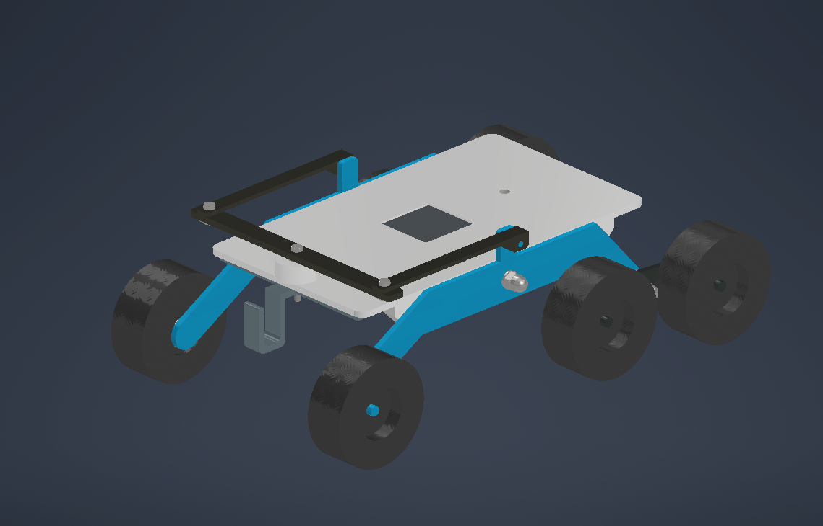
24 Figure Final model 1
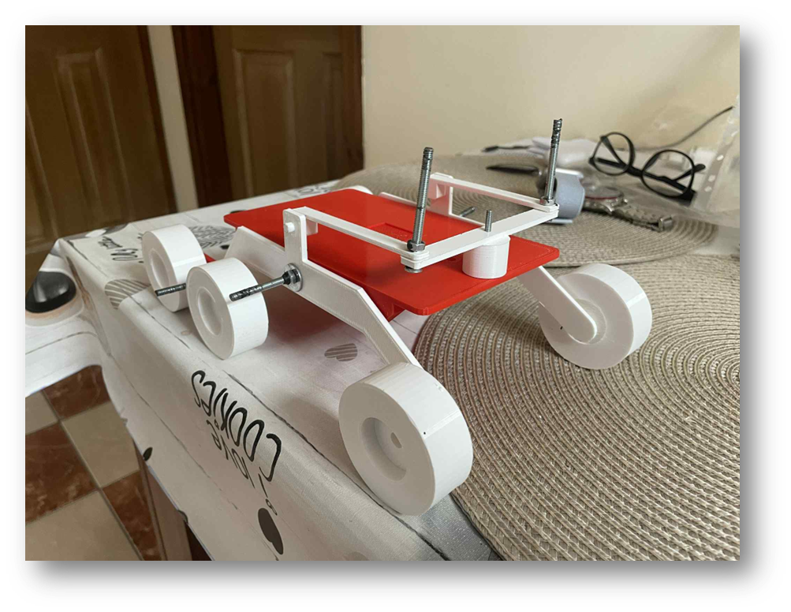
25 Final assembly 1
Dimensions
Length: 267.122 mm
Height: 130.25 mm
Width: 138 mm

Final Cost Expenditure
Budget Plan
Screws | 10HUF/each - 170HUF
Nuts | 5HUF/each - 85HUF
Washers | 2.5HUF/each - 42.5HUF
PLA Filament | 400g around 4000-5000HUF
Total Cost | 5297.5HUF
- Tire cost was reduced because, the tires were printed. That reduced the total cost in half.

Sources
Microsoft Word - CP-2004-212073.DOC
https://sandersonleafsprings.co.uk/leaf-spring-advantages-and-disadvantages
https://en.wikipedia.org/wiki/MacPherson_strut
https://www.carparts.com/blog/what-is-a-macpherson-strut-suspension-plus-other-related-faqs/
https://aldanamerican.com/blog/6-facts-about-the-macpherson-strut-you-can-impress-your-friends-with/
https://ateupwithmotor.com/terms-technology-definitions/macpherson-strut-history/
https://automotiveamerican.com/2024/10/14/earl-macpherson-and-the-macpherson-strut-suspension-system/

